# CS 255 System Design Document Template

This template lays out all the different sections that you need to complete for Project Two. Each section has guidance to prompt your thinking. You will need to continually reference the interview transcript as you work to make sure that you are addressing your client’s needs. There is no required length for the final document. Instead the goal is to complete each section based on what your client’s needs are. Remove this note when you are finished, and replace all bracketed text with the relevant information.

## UML Diagrams

### UML Use Case Diagram

### UML Activity Diagrams

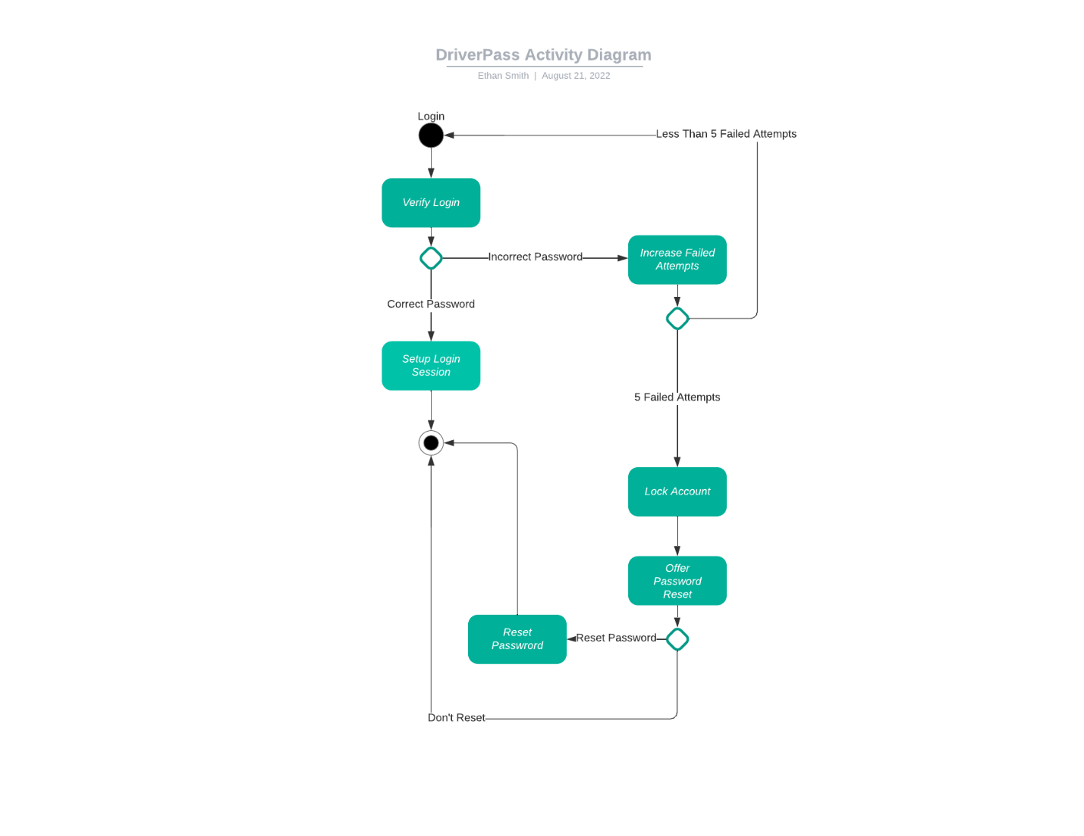***Login Activity Diagram***

***Make Appointment Activity Diagram***

### UML Sequence Diagram

### UML Class Diagram

## Technical Requirements

* Most CPUs available with dedicated servers or cloud computing will be enough to run the software smooth but the latest Xeon E5 CPUs from Intel would work most efficiently.
* Ram isn’t as important for web software but a dedicated server with anywhere from 32-128GB of ram would be viable. If the cloud computing route is chosen, then ram can be scaled as needed starting with 8GB most likely.
* A dedicated server running Linux or cloud infrastructure provider such as AWS or Google Cloud to host the database and web software on.
* MySQL or MariaDB will need to be installed on the chosen infrastructure for the software’s database.
* A payment processor such as Stripe, PayPal, or other would be required for processing payments for packages.
* Internet will be needed at all times to host the software as well as use it.